Learning outcome- able to design and develop dynamic websites with PHP
After achieving this learning outcome, a student will be able to design and develop dynamic websites with PHP. In order to achieve this learning outcome, a student has to complete the following:

Activities:
- Capturing Form Data Dealing with Multi-value field Generating File uploaded form (2 Hrs)
- Redirecting a form after submission (2 Hrs)
- Write a PHP script to get the PHP version and configuration information (30 mins)
- Write a PHP script to display the strings (1 Hr)
- Create a simple HTML form and accept the user name and display the name through PHP echo statement (1 Hrs)
- Write a e PHP script to display string, values within a table (2 Hrs)
- Write a PHP script to count lines in a file (30 mins)
- Write a PHP function to test whether a number is greater than 30, 20 or 10 using ternary operator (1 Hr)
- Write a script which will display the string ( 1 Hr)
- Write a PHP script which will display the array ( 2 Hrs)
- Write a PHP script to sorting (2 Hrs)
- Write a PHP script to calculate and display average temperature, five lowest and highest temperatures in given data (2 Hr)
- Write a program to calculate and print the factorial of a number using a for loop (2 Hr)
- Write a PHP script using nested for loop (1 Hrs)
- Write a PHP program to generate and display the first n lines of a Floyd (2 Hrs)
- Write a function to calculate the factorial of a number (2 Hr)
- Write a function to check a number is prime or not(1Hr)

Activity 1
Aim: Capturing Form Data Dealing with Multi-value field Generating File uploaded form
Learning outcome: Able to design and develop dynamic websites with PHP.
Duration: 2 hour

List of Hardware/Software requirements:
- Laptop/Computer with Linux OS - Ubuntu 18.04 LTS/Windows
- Apache 7.4 or above

Program:
//6 form.php example
<html>
<body>
<form action="6 form.php" method="post">
First Name: <input type="text" name="name"><br><br> Last Name: <input type="text" name="lname"><br><br>
<input type="submit">
</form>
</body>
</html>
<html>
<body>
Welcome <?php echo $_POST["name"]." "; ?>
<?php echo $_POST["lname"]; ?>
</body>
</html>

Output/Results snippet:

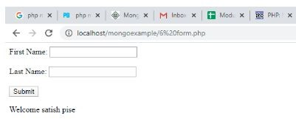

References:
    - HTML Introduction - https://www.w3schools.com/
    - PHP - https://www.w3schools.com/

// Example 2 multi field
<form action="2.php" method="post">
<h2>What are your favorite soft drink?</h2>
<label>Coke</label>
<input type="checkbox" name="drink[]" value="coke" />
<label>Sprite</label>
<input type="checkbox" name="drink[]" value="sprite" />
<label>Root Beer</label>
<input type="checkbox" name="drink[]" value="root beer" />
<label>Orange Juice</label>
<input type="checkbox" name="drink[]" value="orange juice" />
<label>Apple Juice</label>
<input type="checkbox" name="drink[]" value="apple juice" />
<label>Water</label>
<input type="checkbox" name="drink[]" value="water" />

<h2>What are your favorite soft drink?</h2>
<select name="favor[]" size = "4" multiple = "multiple">
<option value="coke">Coke</option>
<option value="sprite">Sprite</option>
<option value="root beer">Root Beer</option>
<option value="orange juice">Orange Juice</option>
<option value="apple juice">Apple Juice</option>
<option value="water">Water</option>
</select>
<p>Note that hold a <b>ctrl</b> key to choose more than one item.</p>
<input type="submit" name="submit" id="moveRight" value="Submit" />
<input type="reset" name="reset" value="Reset" style="margin-left: 20px;display:inline;" />
</form>
<?php
$drinklist=$_POST["drink"]; //assign an array to a local array
$favorlist=$_POST["favor"];
echo "Your favorite drink from checkboxes are <br />"; foreach($drinklist as $drink)
echo $drink . "<br /> "; echo "<br />";
echo "Your favorite drink from pull-down menu are <br /> "; foreach($favorlist as $favor)
echo $favor. "<br />";
?>

Output/Results snippet:
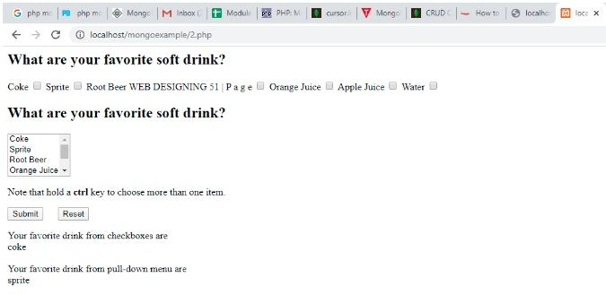

References:
    - HTML Introduction - https://www.w3schools.com/
    - PHP - https://www.w3schools.com/

// File Upload example html form
<!DOCTYPE html>
<html>
<body>
<form action="6-3upload.php" method="post" enctype="multipart/form-data"> Select image to upload:
<input type="file" name="fileToUpload" id="fileToUpload">
<input type="submit" value="Upload Image" name="submit">
</form>
</body>
</html>

//File upload php file
<?php
$target_dir = "uploads/";
$target_file = $target_dir . basename($_FILES["fileToUpload"]["name"]);
$uploadOk = 1;
$imageFileType = strtolower(pathinfo($target_file,PATHINFO_EXTENSION));
// Check if image file is a actual image or fake image if(isset($_POST["submit"])) {
$check = getimagesize($_FILES["fileToUpload"]["tmp_name"]); if($check !== false) {
echo "File is an image - " . $check["mime"] . ".";
$uploadOk = 1;
} else {
echo "File is not an image.";
$uploadOk = 0;
}
}?>

Output/Results snippet:

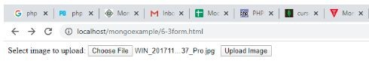

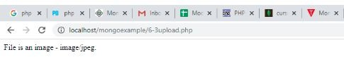

References:
    - HTML Introduction - https://www.w3schools.com/
    - PHP - https://www.w3schools.com/

Activity 2
Aim: Redirecting a form after submission
Learning outcome: Able to design and develop dynamic websites with PHP.
Duration: 2 hour

List of Hardware/Software requirements:
- Laptop/Computer with Linux OS - Ubuntu 18.04 LTS/Windows
- Apache 7.4 or above

Program:
<html>
<body>
<form action="https://google.com" method="POST">
<input type="hidden" name="fullname" value="john" />
<input type="hidden" name="address" value="street 2, 32 ave" />
<input type="submit" value="Submit request" />
</form>
</body>
</html>

Output/Results snippet:
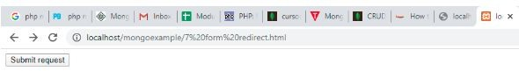

//PHP redirection – redirect_form.php
<!DOCTYPE html>
<html>

<head>
<title>Redirect Form To a Particular Page On Submit - Demo Preview</title>
<meta content="noindex, nofollow" name="robots">
<link href='css/redirect_form.css' rel='stylesheet' type='text/css'> <!--== Include CSS File Here ==-->
</head>
<body>
<div class="main">
<div class="first">
<h2>Redirect Form To a Particular Page On Submit using PHP</h2>
<form action="redirect_form.php" id="#form" method="post" name="#form">
<label>Name :</label>
<input id="name" name="name" placeholder='Your Name' type='text'>
<label>Email :</label>
<input id="email" name="email" placeholder='Valid Email Address' type='text'>
<label>Contact :</label>
<input id="contact" name="contact" placeholder='Contact' type='text'>
<label>Address:</label>
<input id="address" name="address" placeholder='Address' type='text' value="">
<input id='btn' name="submit" type='submit' value='Submit'>
<!---- Including PHP File Here >
<?php
include "redirect.php";
?>
</form>
</div>
</div>
</body></html>

//Redirect.php
<?php if(isset($_POST['submit'])){
// Fetching variables of the form which travels in URL
$name = $_POST['name'];
$email = $_POST['email'];
$contact = $_POST['contact'];
$address = $_POST['address'];
if($name !=''&& $email !=''&& $contact !=''&& $address !='')
{
// To redirect form on a particular page header("Location:https://www.formget.com/app/");
}
else{
?><span><?php echo "Please fill all fields !!!!!!!!!!!!";?></span> <?php
}
}
?>

Output/Results snippet:
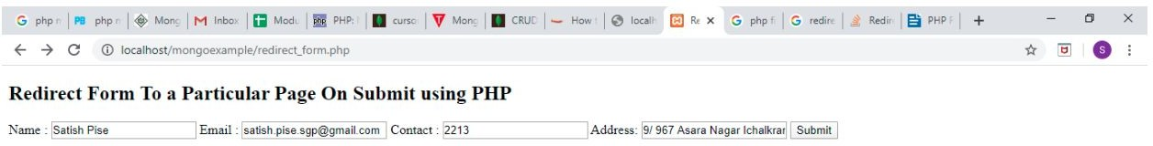

References:
    - HTML Introduction - https://www.w3schools.com/
    - PHP - https://www.w3schools.com/
Activity 3
Aim: Write a PHP script to get the PHP version and configuration information
Learning outcome: Able to design and develop dynamic websites with PHP.
Duration: 30 mins

List of Hardware/Software requirements:
- Laptop/Computer with Linux OS - Ubuntu 18.04 LTS/Windows
- Apache 7.4 or above

Program:
<?php phpinfo();
?>

Output/Results snippet:
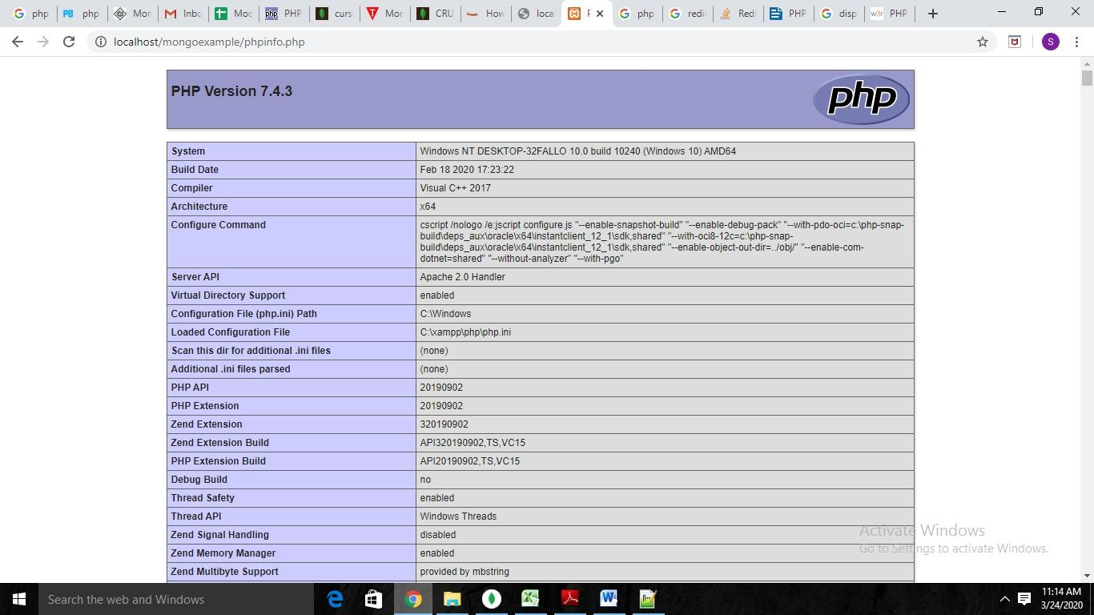
References:
    - HTML Introduction - https://www.w3schools.com/
    - PHP - https://www.w3schools.com/
Activity 4
Aim: Write a PHP script to display the strings (Notepad)
Learning outcome: Able to design and develop dynamic websites with PHP.
Duration: 1 hour

List of Hardware/Software requirements:
- Laptop/Computer with Linux OS - Ubuntu 18.04 LTS/Windows
- Apache 7.4 or above

Program:
<?php
echo strtolower("Hello WORLD.<br>"); echo strtoupper("Hello WORLD!<br>"); echo "Php Strings."."\n";
echo "This is a bad command : del c:\\*.*"."\n"; echo lcfirst("Hello world!<br>");
$str = "Hello"; echo md5($str);
$arr = array('Hello','World!','Beautiful','Day!'); echo join(" ",$arr);
?>

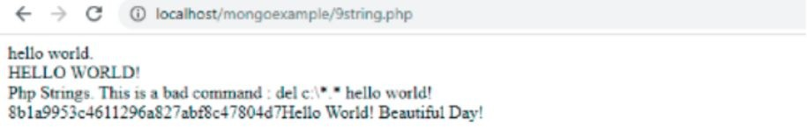
Output/Results snippet:

References:
    - PHP - https://www.w3schools.com/
    - https://www.tutorialrepublic.com/faq/how-to-create-a-new-line-in-php.php
Activity 5
Aim: Create a simple HTML form and accept the user name and display the name through PHP echo statement
Learning outcome: Able to design and develop dynamic websites with PHP.
Duration: 1 hour

List of Hardware/Software requirements:
- Laptop/Computer with Linux OS - Ubuntu 18.04 LTS/Windows
- Apache 7.4 or above

Program:
Userform.html
<html>
<body>
<form action="10formphp.php" method="post"> Name: <input type="text" name="name"><br>
<input type="submit">
</form> </body>
</html> Formphp.php
<?php
echo $_POST["name"];
?>

Output/Results snippet:
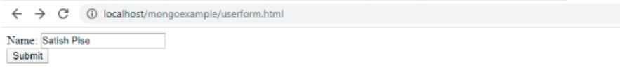

References:
    - PHP - https://www.w3schools.com/
    - https://www.tutorialrepublic.com/faq/how-to-create-a-new-line-in-php.php

Activity 6
Aim: Write a PHP script to display string, values within a table
Learning outcome: Able to design and develop dynamic websites with PHP
Duration: 2 Hrs

List of Hardware/Software requirements:
- Laptop/Computer with Linux OS - Ubuntu 18.04 LTS/Windows
- Notepad++
- Xampp Server.

Program 1:
<?php
$a=100;
$b=50;
$c=20;
echo "<table border=1 cellspacing=0 cellpading=0>
<!— column which spans 2 -->
<tr> <th colspan= 2> Marks Sheet </th></tr>
<tr> <td><font color=blue>Marks of Mr. A is</td>
<td>$a</font></td></tr>
<tr> <td><font color=blue>Marks of Mr. B is</td>
<td>$b</font></td></tr>
<tr> <td><font color=blue>Marks of Mr. C is</td>
<td>$c</font></td></tr>
</table>";
?>

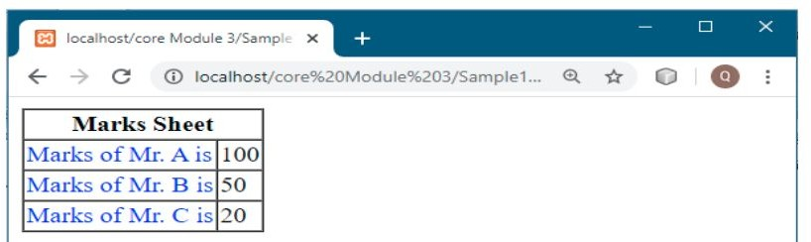
Output/Results snippet:

Program 2:
<?php
echo "<table border=1 cellspacing=0 cellpading=0>
<tr>
<th>Name</th>
<td>Diploma Course</td>
</tr>
<tr>
<!— row which spans 2 -->

<th rowspan=2>Offered by</th>
<td>IBM</td>
</tr>
<tr>
<td>Edunet</td>
</tr>";
?>

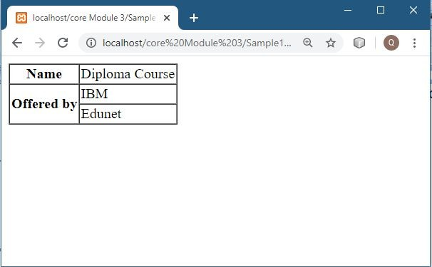
Output/Results snippet:
Reference:
    - https://www.w3resource.com/php-exercises/php-basic-exercise-13.php
Activity 7
Aim: Write a PHP script to count lines in a file
Learning outcome: Able to design and develop dynamic websites with PHP
Duration: 30 mins

List of Hardware/Software requirements:
- Laptop/Computer with Linux OS - Ubuntu 18.04 LTS/Windows
- Notepad++
- Xampp Server

Program:
<?php
// nl2br is used for newlines.
echo nl2br("Hi NSTI \n");
echo nl2br("Hi NSTI \n");
$file = basename($_SERVER['PHP_SELF']);
$no_of_lines = count(file($file));
echo "There are $no_of_lines lines in $file"."\n";
?>

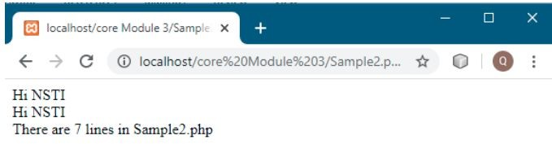
Output/Results snippet:

Reference: https://www.w3resource.com/php-exercises/php-basic-exercise-16.php
Activity 8
Aim: Write a PHP function to test whether a number is greater than 30, 20 or 10 using ternary operator
Learning outcome: Able to design and develop dynamic websites with PHP
Duration: 1 Hrs

List of Hardware/Software requirements:
- Laptop/Computer with Linux OS - Ubuntu 18.04 LTS/Windows
- Notepad++
- Xampp Server

Program 1:
<?php
// Declaring a function called Test function trinary_Test($n){
$r = $n > 30
? nl2br("greater than 30 \n")
: ($n > 20
? nl2br("greater than 20 \n")
: ($n >10
? nl2br("greater than 10 \n")
: "Input a number atleast greater than 10!")); echo $n." : ".$r."\n";
}
// Calling the function Test trinary_Test(32);
trinary_Test(21); trinary_Test(12);
trinary_Test(4);
?>

Output/Results snippet:

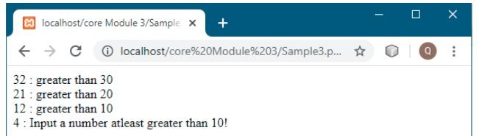

Program 2: Example of Ternary operators
<?php
$marks=50;
// using the print in php to display the output print ($marks>=40) ? "Pass" : "Fail";
?>

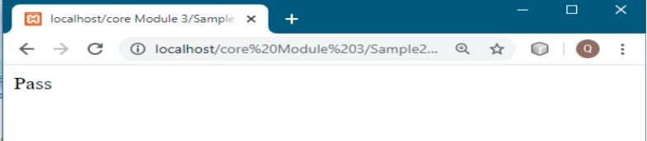
Output/Results snippet:

Reference:
    - https://www.w3resource.com/php-exercises/php-basic-exercise-21.php

Activity 9

Aim: Write a script which will display the string.
Learning outcome: Able to design and develop dynamic websites with PHP
Duration: 1 hour

List of Hardware/Software requirements:
- Laptop/Computer with Linux OS - Ubuntu 18.04 LTS/Windows
- Notepad++
- Xampp Server

Program:

<?php
// using the echo in php to display the output echo "<h2>PHP is Fun!</h2>";
echo "Hello world!<br>";
echo "I'm about to learn PHP!<br>";
echo "This ", "string ", "was ", "made ", "with multiple parameters.";
// using the echo in php to display the output print "<h2>PHP is Fun!</h2>";
print "Hello world!<br>";
print "I'm about to learn PHP!";
?>

Output/Results snippet:
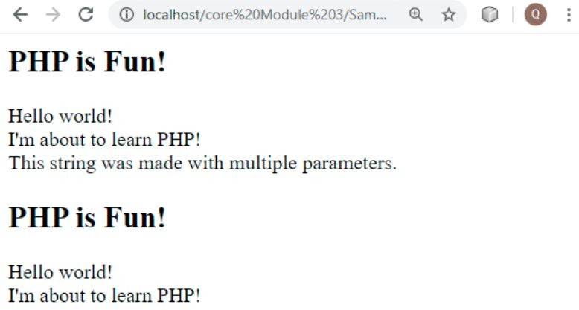
References:
    - https://www.w3schools.com/
    - https://www.w3resource.com/

Activity 10
Aim: Write a PHP script which will display the array.
Learning outcome: Able to design and develop dynamic websites with PHP
Duration: 2 hours

List of Hardware/Software requirements:
- Notepad++
- Xampp Server

Program:
<?php
// Declaring a array
$color = array('white', 'green', 'red');
// using the foreach loop to loop through in array foreach ($color as $c)
{
echo "$c, "; }
sort($color); // Sorting the array
// Displaying the content of array in unordered list echo "<ul>";
foreach ($color as $y)
{ echo "<li>$y</li>";
} echo "</ul>";
?>

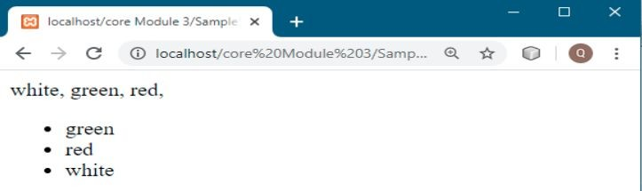
Output/Results snippet:
Reference:
    - https://www.w3resource.com

Activity 11

Aim: Write a PHP script to sorting

Learning outcome: Able to design and develop dynamic websites with PHP
Duration: 2 Hrs

List of Hardware/Software requirements:
- Notepad++
- Xampp Server

Program:
<?php
// Writing the function to sort an array
// This function requires the parameter function insertion_Sort($my_array)
{
for($i=0;$i<count($my_array);$i++){
$val = $my_array[$i];
$j = $i-1;
while($j>=0 && $my_array[$j] > $val){
$my_array[$j+1] = $my_array[$j];
$j--;
}
$my_array[$j+1] = $val;
}
return $my_array;
}
//Writing the array which need to be sort
$test_array = array(3, 0, 2, 5, -1, 4, 1); echo "Original Array :\n";
echo implode(', ',$test_array ); echo "\nSorted Array :\n";
//Calling the function with parameter
//Displays the content of array in sorted manner print_r(insertion_Sort($test_array));
?>

Output/Results snippet:
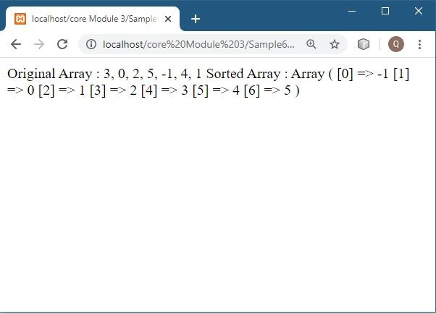

Reference:
    - https://www.w3resource.com

Activity 12

Aim: Write a PHP script to calculate and display average temperature, five lowest and highest temperatures in given data
Learning outcome: Able to design and develop dynamic websites with PHP
Duration: 2 Hrs

List of Hardware/Software requirements:
- Notepad++
- Xampp Server

Program:
<?php
echo "<pre>";
// Hard coded values for temperature
$temperatures = array(78, 60, 62, 68, 71, 68, 73, 85, 66, 64, 76, 63, 75, 76, 73, 68, 62, 73, 72, 65, 74,
62, 62, 65, 64, 68, 73, 75, 79, 73);
// Declaring a parameterized function
// Function name is listvalues
function listvalues($value)
{
echo "$value, ";
}
// Function name is printAverage
function printAverage($array)
{
$total = 0;
foreach($array as $element)
{
$total += $element;
}
echo number_format($total / count($array), 1);
}
echo "Recorded temperatures : "; array_walk($temperatures, "listvalues"); echo "<br>";
// Displaying the average of given temperatures echo "Average Temperature is: "; printAverage($temperatures);echo "<br>";

//sort the temperatures in ascending order for both of the following lists. sort($temperatures);
//print the first 5 values
echo "List of five lowest temperatures : "; for($i = 0; $i < 5; $i++)
{
echo "$temperatures[$i], ";
}
echo "<br>";
//print the last 5 values
echo "List of five highest temperatures : ";
for($i = count($temperatures) - 5; $i <= count($temperatures) - 1; $i++)
{
echo "$temperatures[$i], ";
}
echo "<br>"; echo "</pre>";
?>

Output/Results snippet:
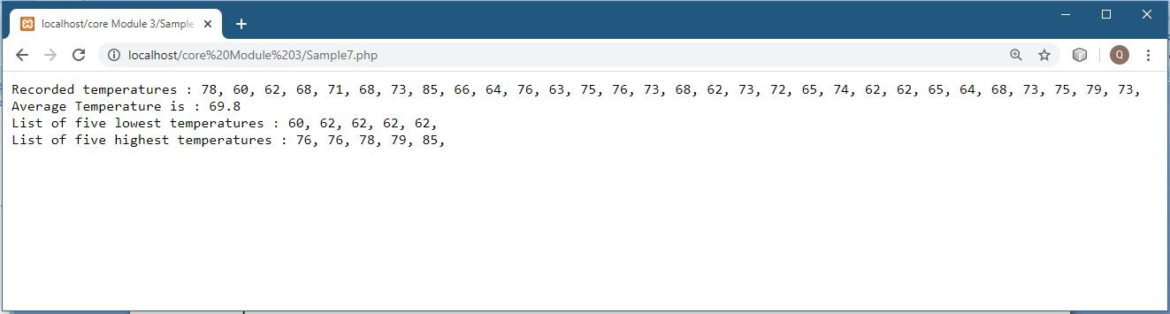

Reference:
    - https://www.w3resource.com

Activity 13
Aim: Write a program to calculate and print the factorial of a number using a for loop.
Learning outcome: Able to design and develop dynamic websites with PHP
Duration: 2 Hrs

List of Hardware/Software requirements:
- Notepad++
- Xampp Server

Program:
<?php
// Declaring a variable whose factorial is to be find
$n = 6;
$x = 1;
//Calculating the factorial of a given number for($i=1;$i<=$n-1;$i++)
{
$x*=($i+1);
}
// Displaying the factorial of a given number echo "The factorial of $n = $x"."\n";
?>

Output/Results snippet:
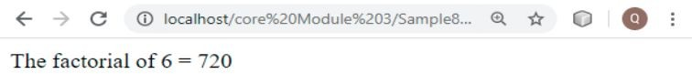

Reference:
    - https://www.w3resource.com

Activity 14
Aim: Write a PHP script using nested for loop
Learning outcome: Able to design and develop dynamic websites with PHP
Duration: 1 Hrs

List of Hardware/Software requirements:
- Notepad++
- Xampp Server

Program:
<?php
$n=5;
// A for loop
for($i=1; $i<=$n; $i++)
{
//Declaring a for loop inside in the another for loop
// A nester for loop for($j=1; $j<=$i; $j++)
{
echo ' * ';
}
echo nl2br("\n");
}
// A for loop for($i=$n; $i>=1; $i--)
{
//Declaring a for loop inside in the another for loop
// A nester for loop for($j=1; $j<=$i; $j++)
{
echo ' * ';
}
echo nl2br("\n ");
}
?>

Output/Results snippet:
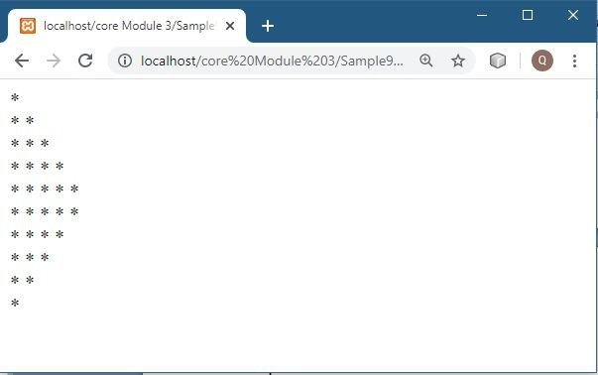

Reference:
    - https://www.w3resource.com

Activity 15

Aim: Write a PHP program to generate and display the first n lines of a Floyd
Learning outcome: Able to design and develop dynamic websites with PHP
Duration: 2 Hrs

List of Hardware/Software requirements:
- Notepad++
- Xampp Server

Program:
<?php
// Declaring number of lines we need in a triangle
$n = 5;
echo "n = " . $n . "<br>";
//Specifying from where we need to print
$count = 1;
for ($i = $n; $i > 0; $i--)
{
for ($j = $i; $j < $n + 1; $j++)
{
printf("%4s", $count);
$count++;
}
echo "<br>";
}
?>

Output/Results snippet:
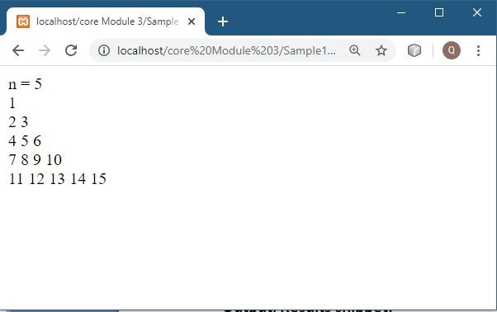

References:
    - https://www.w3resource.com/php-exercises/php-for-loop-exercise-12.php
    - https://www.w3resource.com/php-exercises/
    - https://www.w3schools.com/php/default.asp
    - https://www.javatpoint.com/php-tutorial
Activity 16
Aim: Write a function to calculate the factorial of a number
Learning outcome: Able to design and develop dynamic websites with PHP.
Duration: 2 hour

List of Hardware/Software requirements:
- Laptop/Computer with Linux OS - Ubuntu 18.04 LTS/Windows
- Lamp Server with PHP

Program:
<?php
// PHP code to get the factorial of a number
// function to get factorial in iterative way function Factorial($number){
if($number <= 1){
return 1;
}
else{
return $number * Factorial($number - 1);
}
}
// Driver Code
$number = 10;
$fact = Factorial($number); echo "Factorial = $fact";
?>

Output/Results snippet:
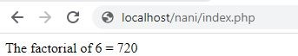

References:
1. https://www.javatpoint.com/php-factorial-program

Activity 17
Aim: Write a function to check a number is prime or not
Learning outcome: Able to design and develop dynamic websites with PHP.
Duration: 1 hour

List of Hardware/Software requirements:
- Laptop/Computer with Linux OS - Ubuntu 18.04 LTS/Windows
- LAMP Server with PHP

Program:
<?php
function primeCheck($number){ //creating a function primeCheck
if ($number == 1)
return 0;
for ($i = 2; $i <= $number/2; $i++){ if ($number % $i == 0)
return 0; }
return 1;
}
$number = 31; //input number 31
$flag = primeCheck($number); //checking prime or not
if ($flag == 1)
echo "$number is Prime"; else
echo "$number is Not Prime"
?>

Output/Results snippet:
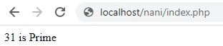

References:
1. https://www.w3resource.com/php-exercises/php-function-exercise-2.php

